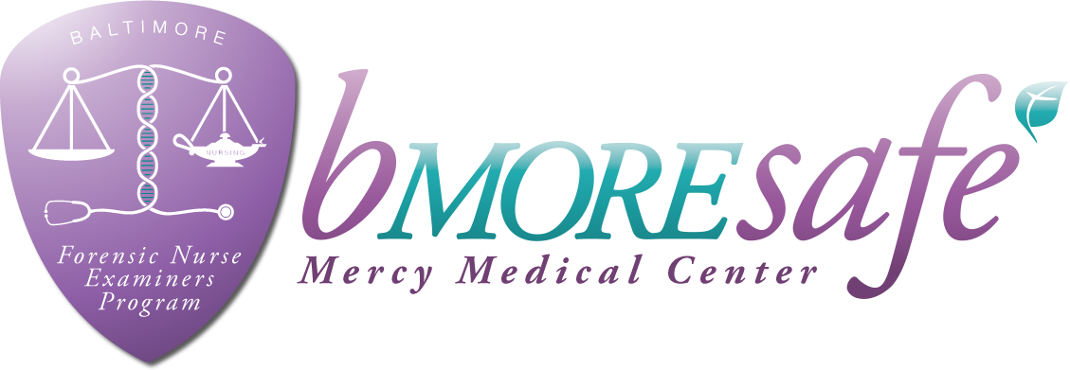
Forensic Nurse Examiner Training – Adult & Adolescent
24 HOURS ON-LINE / 16 HOURS IN-CLASS

CLASS DATES FOR 2023 (8am- 4:30pm)
Twenty-Four hours of online training to be completed before the classroom training
- April 5 & 6, 2023
- August 7 & 8, 2023
- November 9 & 10, 2023

LOCATION: MERCY MEDICAL CENTER
301 Saint Paul Place, Baltimore, Maryland 21202
Or Hybrid option Online
COST: $350.00 which includes all course materials
Lectures by nationally recognized forensic nursing instructors & local criminal justice agencies
Maryland Board of Nursing approved 40 CEUs
PAYMENT OPTIONS:
CHECK: Payable to Mercy Forensic Department (OR)
MONEY ORDER: Payable to MMC, 301 St. Paul Place, Baltimore, MD 21202 (OR)
Visit bmoresafemercy.org, Events page to register and use Paypal option for payment.
paypal.com/us/fundraiser/charity/2430993 (This is the charity donation link for Mercy)
For questions or concerns regarding this training, please call (410) 332-9494
Name: ____________________________________________________________________________________
Affiliation: ________________________________________________________________________________
Address: __________________________________________________________________________________
Telephone: ____________________________________________ Email:________________________________________________
How did you hear about our program? ______________________________________
Will you be attending in person or online?___________________________________
SEND PAYMENT AND REGISTRATION TO: Mercy Medical Center FNE Program
aboss@mdmercy.com
CLASS FEES ARE NON-REFUNDABLE

View the FNE program online: www.bmoresafemercy.org &
Mercy Forensic Nurse Examiners – bmoresafe

