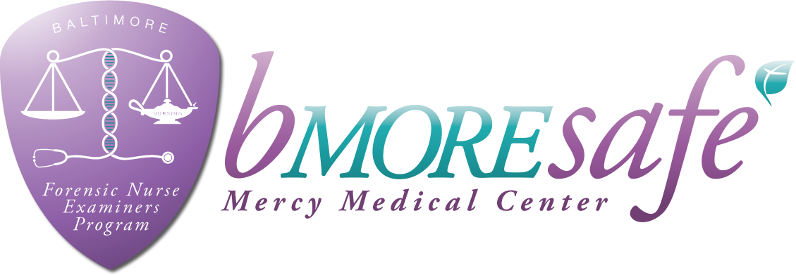

**Forensic Nurse Examiner Training – Adult & Adolescent**

**24 Hours. ON-LINE / 16 Hours IN-CLASS**

**(ONLY HYBRID CLASS APPOVED IN MARYLAND)**

**View the FNE program online:** [www.bmoresafemercy.org](http://www.bmoresafemercy.org) **&**  **Mercy Forensic Nurse Examiners – bmoresafe**

**CLASS DATES FOR 2019 (8am- 4:30pm)**

* **March 12th & 13th**
* **August 7TH & 8TH,**
* **November 6TH & 7TH**

Twenty-Four hours online training to be completed prior to classroom training

**LOCATION: MERCY MEDICAL CENTER**

**301 Saint Paul Place, Baltimore, Maryland 21202**

**COST: $350 which includes**

**All course materials**

**16** **hours didactic and 24 hours online web based training by nationally-recognized forensic nursing instructors & local criminal justice agencies**

**Maryland Board of Nursing approved 40 CEUs**

|  |
| --- |
| **PAYMENT OPTIONS: PAYPAL ACCOUNT:** [**Mercysafe@gmail.com**](mailto:Mercysafe@gmail.com)  **If using PayPal cost is $360 (OR)**  **CHECK: Payable to Mercy Forensic Department (OR)**  **MONEY ORDER: Payable to MMC c/o Debra Holbrook, 301 St. Paul Place, Baltimore, MD 21202**  For questions or concerns regarding this training, please e-mail: **ccooley@mdmercy.com**  Name: ____________________________________________________________________________________  Affiliation: ________________________________________________________________________________  Address: __________________________________________________________________________________  Telephone: ____________________________________________ Email:________________________________________________  How did you hear about our program? ___________________________________________________________  **SEND PAYMENT AND REGISTRATION TO: Mercy Medical Center FNE Program**  CLASS FEES ARE NON-REFUNDABLE |